TASK 2: API Integration & JSON Handling

Student Details:
Name: G HARINI
Course: B.Tech - Computer Science and Engineering
Domain: Python Developer Intern
Aim
The aim of this task is to implement API integration and JSON handling using Python. It demonstrates fetching online data using APIs, parsing JSON responses, applying search/filter logic, and handling errors using exception handling.

Tools Used
- Python 3.x
- VS Code (Code Editor)
- Requests Library
- JSON API

PROCEDURE
- Initialized the Python program and imported the requests module.
- Connected to the online API using requests.get().
- Fetched user data from the API endpoint.
- Converted JSON response into Python data using json parsing.
- Displayed user details such as ID, Name, and Email.
- Implemented search functionality using User ID.
- Handled invalid inputs and API errors using try-except blocks.
- Verified successful execution through terminal output.

Code
import requests
url = "https://jsonplaceholder.typicode.com/users"
try:
response = requests.get(url)
users = response.json()
print("\nUSER DATA\n")
# Display only first 5 users
for user in users[:5]:
print("ID :", user['id'])
print("Name :", user['name'])
print("Email :", user['email'])
print("-" * 30)
search_id = int(input("\nEnter User ID to search: "))
found = False
for user in users[:5]:
if user['id'] == search_id:
print("\nUSER FOUND")
print("Name :", user['name'])
print("Email :", user['email'])
print("City :", user['address']['city'])
found = True
break
if not found:
print("User not found")
except requests.exceptions.RequestException:
print("API connection error")
except ValueError:
print("Please enter a valid number")

Screenshots: (Code)
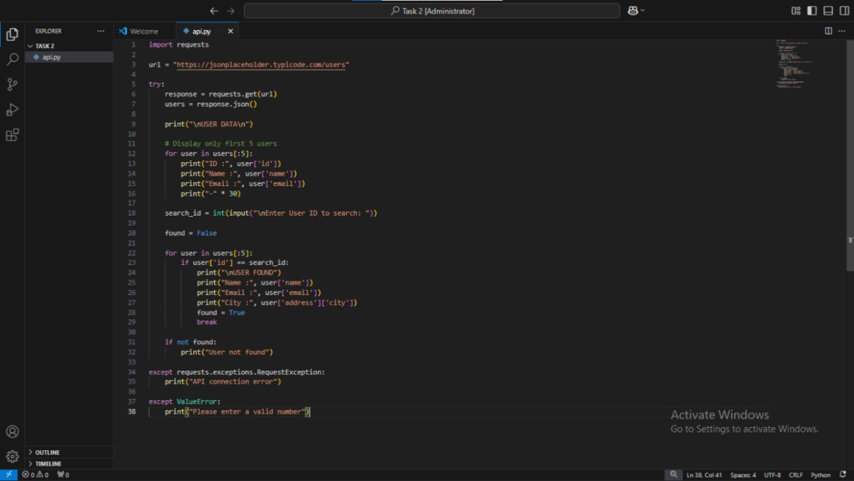
(Output )
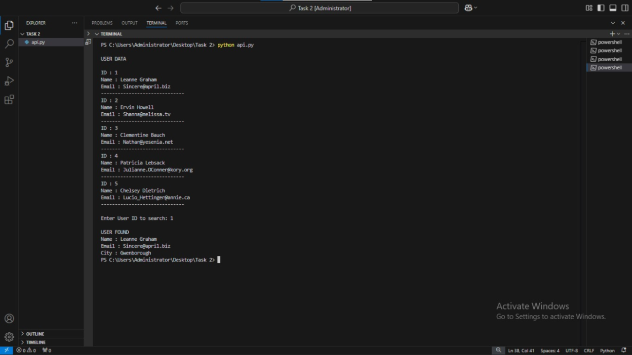

(Error Handling)
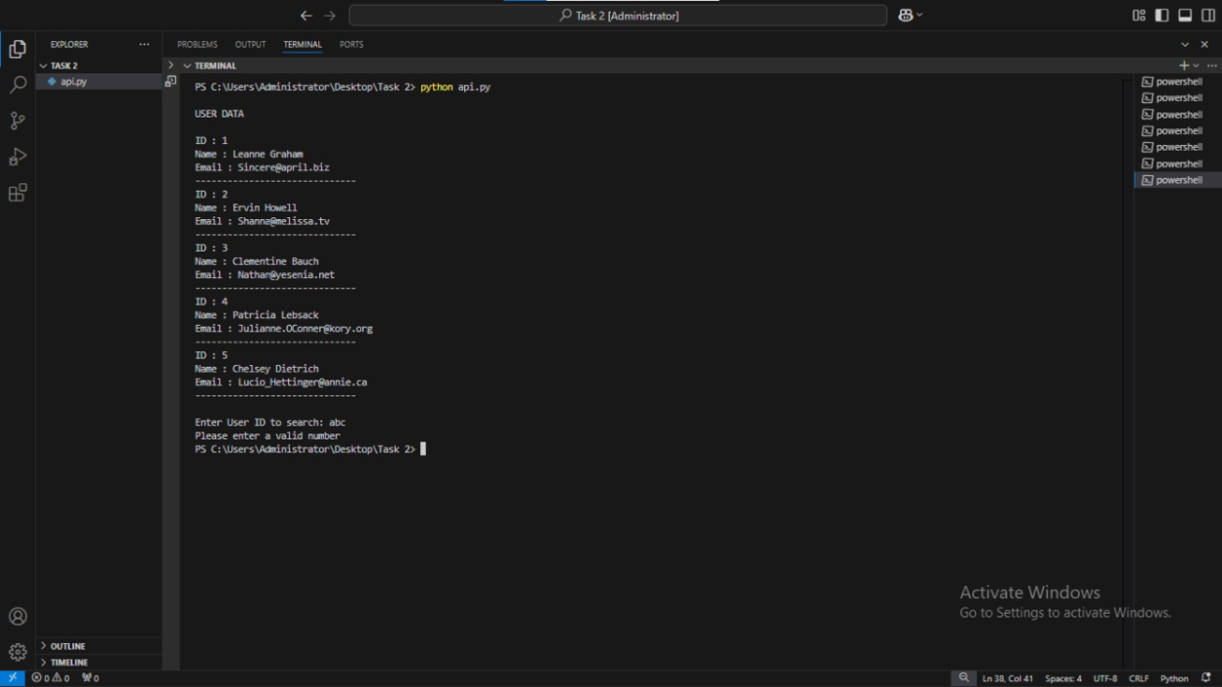
(System proof)


(Folder Structure)
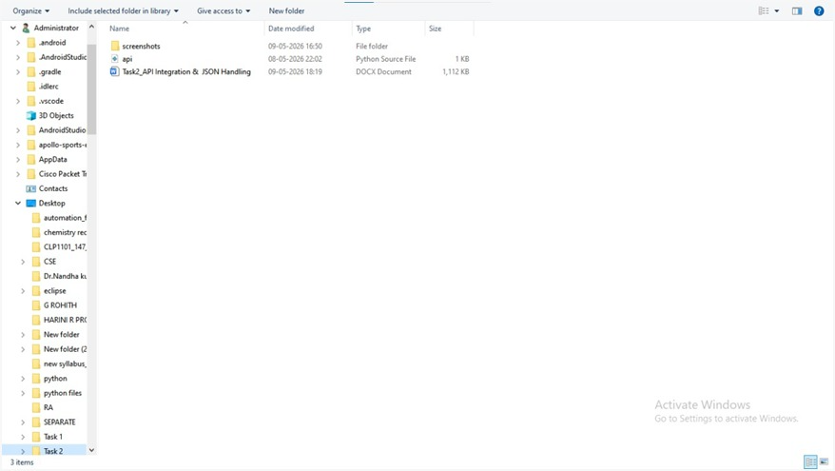

GitHub Link

https://github.com/HariniG4107/python-internship-tasks.git

Conclusion
This task demonstrated how Python can communicate with external APIs and process JSON data effectively. It also showed the implementation of filtering/search logic and exception handling for reliable execution. Overall, the project provided practical knowledge of API integration using Python.

